9.87: The moment of inertia of the hoop about the nail is 2MR(see Exercise 9.52), and the initial potential energy with respect to the center of the loop when its center is directly below the nail is gR (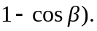 From the work-energy theorem,
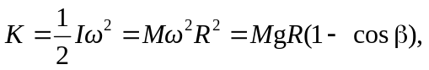
from which 